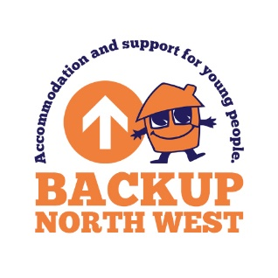

**Request for a copy of informaiton held on a young person**

**Subject Access Request**

As part of BACKUP’s compliance with the Data Protection legislation, everyone who has a relationship with the charity has the right to be provided with a copy of the current personal information held on them for data processing.

We will endeavour to provide a copy of the data requested within five working days of receipt of a written request; however, some requests may require more time to collate all the information. In all instances we will respond promptly and, in any event, no later than one month from receipt of the written request, as stipulated in the legislation.

|  |  |  |  |  |  |
| --- | --- | --- | --- | --- | --- |
| Date of request | |  | | | |
|  | |  | | | |
| Name of person making the request | | | |  | |
|  | | | |  | |
| Please list any other names you may have been known by in your dealings with BACKUP | | |  | | |
|  | | |
|  | | |
|  | | |  | | |
| Address |  | | | | |
|  |  | | | | |
|  |  | | | | |
|  |  | | | | |
|  |  | | | | |
|  |  | | | | |
| Postcode | | | | |  |

|  |  |  |  |
| --- | --- | --- | --- |
| Email |  | | |
|  |  | | |
| Phone number | |  | |
|  | |  | |
| How would you like to receive this information (electronically, or printed and sent by post ?) | | |  |
|  | | |  |
| Do you need the information to be sent by large font, or do you have any other accessibility requirements ? | | |  |
|  | | |  |
| What information do you want a copy of ?  (*Please be specific about the information you’re asking for, and where relevant say what information you don’t need.*) | | | |
|  | | | |
|  | | | |

|  |
| --- |
| Details or dates that will help the organisation find the information you want. |
|  |
|  |
|  |
| The reason you want the information (you don't have to include this but it will help BACKUP find what you need). |
|  |

|  |  |
| --- | --- |
| Your Signature |  |

|  |  |
| --- | --- |
| Date received by Director of Business |  |
|  | |
| Action/Outcome: | |
|  | |
|  | |

This policy is due for renewal on the

1st August 2027

BACKUP NORTH WEST

Bridgeman House, 77 Bridgeman Street, Bolton, BL3 6BY

[www.backup-charity.org.uk](http://www.byphs.org.uk)

Registered Charity Number 1064698. Company Number 3399617.