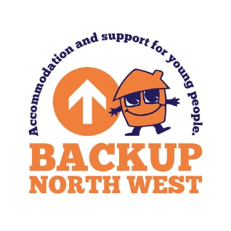
Complaints, comments and compliments

Feedback in the form of complaints, comments and compliments are very important to BACKUP – it helps us to improve the services we offer and sometimes the way we work.

If we provide you with accommodation or support services, please remember that you will not be punished, penalised or victimised for making a complaint or a negative comment.

Anyone who comes into contact with BACKUP can make a complaint, make a comment or pay us a compliment.

This form is for formal complaints; if you wish to make an informal complaint or give us some feedback, speak to a Project Manager or any other member of staff and ask them to pass on the information. We will acknowledge your feedback within a week.

If you wish to make a formal complaint this needs to be in writing and you can use this form.

If you want to, you can talk to someone else, perhaps a worker from another agency, or a friend, and ask them to help. Staff at BACKUP will also help you if you want them to.

After you’ve made a complaint:
- Within one week of BACKUP receiving your complaint – you will be contacted to say that your complaint has been received and you will be told who is going to look into it.
- Within roughly two weeks of BACKUP receiving your complaint - they will look into what you have said.
- Within three weeks of receiving the complaint - you will be written to with a decision. (If you’re not happy with the decision, you can ask for it to be looked at again.)
Your details

Name:
Sex:
Are you under 17 or under ? (please tick) |  |  |  |  |  |  |  | Yes |  | ☐ |  |  |  |  | No | ☐
Because we are registered with Ofsted, it is important that we record complaints from 16 and 17 year olds.
Address
Postcode
Email:
How would you like us to respond ? (please tick)
Email |  | ☐ |  |  | Letter |  | ☐ |  |  |  | No response needed |  |  |  |  |  |  | ☐
Are you submitting (please tick):
A comment ? |  |  |  | ☐ |  | A compliment ? |  |  | ☐ |  |  |  |  | A complaint ? |  |  | ☐

Please tell us about your complaint, comment or compliment here.
(If you need more room the box will expand if you are typing this is in a Word document. If you are filling it in by hand, continue on the reverse or use more pieces of paper.)

Post / or take this form to:  Business Support  BACKUP North West  Bridgeman House  77 Bridgeman Street  Bolton BL3 6BY | Or email it to:  businesssupport@backup-charity.org.uk

If you’re under 18 or a Looked After Child, if things are still not right, you can actually go straight to the Government and contact the Children’s Commissioner.
Help at Hand is the Children’s Commissioner’s advice and assistance service for children in care, children who have a social worker or are working with social services, children living away from home and care leavers.
You can call the Children’s Commissioner on 0800 528 0731

Or contact them through their website – www.childrenscommissioner.gov.uk/help-at-hand/contact

……………………………………………………………………………………………………………………………………………

This form is due for review on the
1st July 2026

BACKUP NORTH WEST
Bridgeman House, 77 Bridgeman Street, Bolton, BL3 6BY.
www.backup-charity.org.uk
Registered Charity Number 1064698. Company Number 3399617

