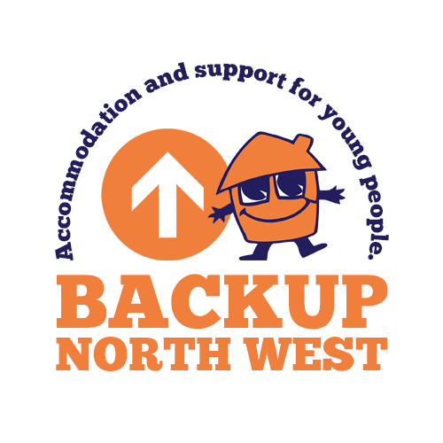
Sassha Application No
For Backup use only

Backup Northwest Referral Form

Date of referral
Name of referrer |  |  | Contact number
Organisation |  |  | Email address
Does the young person need an emergency bed today? |  |  | Yes No
Preferred service
Redds Place The Lofthouse Project Front Door Outreach Supported Lodgings The Lucas Project
Does the young person have a local connection to Bolton? YES NO

Young Person Details
First name |  |  |  | Last name
Date of birth |  |  |  | Age
Contact number |  |  |  | Email
NI number  Essential |  |  |  | Male Female
Proof of ID (what form - passport etc) |  |  |  | Passport number (if known)
MARAC – is the YP Subject to MARAC within last 12 months?

Leaving Care Involvement
Is the young person a “Looked After Child”? |  | Yes |  |  | No
Does the young person have a designated Social Worker ? |  | Yes |  |  | No
Is the young person an Asylum Seeker? |  | Yes |  |  | No
Social Worker’s name |  | Contact number
Please indicate which borough if not Bolton:

Dependants
Please note we can only take referrals including children up to their 1st birthday.
Is the young person pregnant?
Please detail expected due date
Does the young person have a child?
Please detail name and DOB

Income Details |  |  | Current income | Amount / next pay date
Current income | Current income, amount received and next pay date |  | £
Current income | No form of income |  | Benefit application made | YES NO
Does the young person have a bank account? | YES NO

Accommodation History
Previous addresses  If known please give details of ALL known previous addresses with the most recent first | 1.
 | 2.
 | 3.
 | 4.
 | 5.
Supporting/Background Information - Why is this young person in need of a service?
(The box will expand as you type)

Ethnic Origin | White British |  | Asian British |  | Chinese / Other Ethnic
Ethnic Origin | White Irish |  | Asian British/ Bangladeshi |  | Chinese / Other
Ethnic Origin | White Other |  | Asian British/ Indian |  | Mixed White/Asian British
Ethnic Origin | Black British/African |  | Asian British/ Pakistani |  | Mixed White/Black African
Ethnic Origin | Black British/ Caribbean |  | Asian British/ Other |  | Mixed White/Black Caribbean
Ethnic Origin | Black British/ Other |  | Asian Other |  | Mixed Other
Ethnic Origin | Black Other |  | Afghanistan |  | Iranian
 | Iraqi |  | Somalian |  | Syrian
 | Other |  | Please state _______________________________________________

Additional Needs
Please use this section to detail any physical, emotional, learning, social, or visual support needs the young person may have. Please also detail if the young person has an Education and Health Care Plan
Emotional Health and Wellbeing
Please detail any concerns, trauma history and diagnosis. Please include any professional support networks working with the young person in relation to this
Please use this section to detail and risks we need to be aware of so we can provide the right support for the young person.
Risk Factors | Tick if  yes | Details
Substance use
Aggression and violence
Vulnerability
Financial risk
Previous history of arson
Medication risk
Any involvement with the police?
Any other known risk

Any Additional Information
Please use this section to detail any other information you feel we need to be aware of.
Is the young person aware that this referral has been made on their behalf? | YES NO (if no, please give details below)

Contact information of professionals supporting the young person
This should include; Social Workers, HMP Accommodation Officers, Probation Officer, YOT Workers etc
Referrer’s Details
Agency |  | Contact name
Contact no.  Email |  | Job role
Additional Contact 2
Agency |  | Contact name
Contact no.  Email |  | Job role
Additional Contact 3
Agency |  | Contact name:
Contact no.  Email |  | Job role

Once completed please return to businesssupport@backup-charity.org.uk

Referrals to BACKUP North West - Coronavirus (COVID-19) Screening

With the current risk of COVID-19, BACKUP North West aims to maintain fair access to services whilst at the same time manage the risks of illness to other young persons, staff, visitors and volunteers.

As part of the referral/assessment process please could you answer the following questions.

Young person name
Young person date of birth

Yes/No
Has the young person/have you been tested for COVID-19 and awaiting results?

Has the young person/have you had contact with anyone with confirmed COVID-19 in the last 14 days?

Is the young person/are you currently experiencing symptoms of COVID-19?

- Do they have either a high temperature or fever? (Do you feel hot to touch on your chest or back?)

- Do they have a new continuous cough? (This means you’ve started coughing repeatedly)

BACKUP North West recognises that you may not know the answer to these questions, but appreciates you helping us to manage the risks to health presented by the current situation.

BACKUP ADMIN CHECK LIST:

Does the applicant have an existing referral? | Yes No
Is the applicant a former tenant? | Yes Check if arrears/evicted
Has a housing plan been completed by Housing Options? | Yes No

